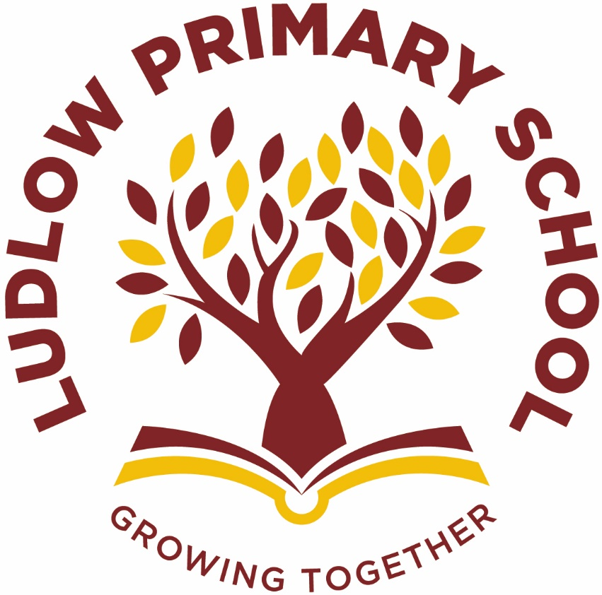

Religious Education at Ludlow Primary School

Our Curriculum Drivers at Ludlow Primary School
Social Skills and Language | Global Identity | Aspirations, resilience and growth mindset | Physical and mental health and well-being
Our Core Values
Independence | Happiness | Honesty | Kindness

When Ludlow Primary School was created in 2019 from the amalgamation of Ludlow Infant and Ludlow Junior School, we had the exciting opportunity to consider our school community’s needs and create a curriculum specifically tailored for them.

We have devised four drivers that run through our school curriculum. They are tailored to our pupil’s specific needs and take account of the opportunities and challenges in the context of our school community and our pupils’ lives.

These join with our core values to help children understand and appreciate the world around them so they can develop into responsible, knowledgeable, and caring international citizens of the 21st century.
C  U  R  R  I  C  U  L  U  M  I  N  T  E  N  T | What RE looks like in our school:  - A balance between Christianity and other faiths is taught across the school.  - Understanding Christianity question units are used to develop the knowledge and understanding of Christianity alongside the Gloucestershire syllabus.  - Wide range of resources are being used in classes for each religion being taught, including faith leaders and places of worship where possible give opportunities to inspire children’s curiosity about the world and its different faiths.  - Children work individually, in pairs and groups to develop knowledge and understanding of the different religions, faiths and belief systems practiced throughout the world.  - We use a wide range of activities to help engage pupils with religion and belief in such a way that they are stimulated to reflect upon and formulate their own beliefs, values and attitudes.  - Learning about the different religions and faiths provide children with the opportunity to explore and investigate the different belief systems and develop a greater understanding of the people around them.  - A well planned ‘Progression of Skills’ through following the Gloucestershire syllabus enable the children to work on and understand different aspects of different religions in each year group.  This is our philosophy:  The principal aim of religious education is to explore what people  believe and what difference this makes to how they live, so that pupils  can gain the knowledge, understanding and skills needed to handle  questions raised by religion and belief, reflecting on their own ideas  and ways of living.  This is the knowledge and understanding gained at each stage:  By the end of EYFS pupils will:  - Children in EYFS should encounter religious and non-religious worldviews through special people, books, times, places and objects and by  - visiting places of worship.  - They should listen to and talk about stories.  - Children can be introduced to subject-specific words and use all their senses to explore beliefs, practices and forms of expression. They ask questions and reflect on their own feelings and experiences.  - They use their imagination and curiosity to develop their appreciation of, and wonder at, the world in which they live.  By the end of Key Stage 1 pupils will:  - Pupils will begin to identify the core beliefs and concepts studied and be able to give a simple description of what they mean.  - They will be able to give examples of how stories show what people believe (e.g. the meaning behind a festival).  - Children will be able to give examples of how people use stories, texts and teachings to guide their beliefs and actions.  - They will be able to give examples of ways in which believers put their beliefs into action.  - Pupils will be able to think, talk and ask questions about whether the ideas they have been studying are relevant to them.  - Pupils will be able to give a good reason for the views they have and the connections they make.  By the end of Key Stage 2 pupils will:  - Children will be able to identify and explain the core beliefs and concepts studied, using examples from sources of authority in religions, to describe examples of ways in which people use texts/sources of authority to make sense of core beliefs and concepts and to give meaning for texts/sources of authority studied, comparing these ideas with ways in which believers interpret texts/sources of authority.  - Pupils will be able to make clear connections between what people believe and how they live, individually and in communities. Using evidence and examples, show how and why people put their beliefs into action in different ways, e.g. in different communities, denominations or cultures.  - Pupils will be able to make connections between the beliefs and practices studied, evaluating and explaining their importance to different people (e.g. believers or atheists), reflect on and articulate lessons people might gain from the beliefs/practices studied including their own responses recognising that others may think differently and be able to consider and weigh up how ideas studied in the units relate to their own experiences and experiences of the world today, developing insights of their own and giving good reasons for the views they have and the connections they make.

C  U  R  R  I  C  U  L  U  M  I  M  P  L  E  M  E  N  T  A  T  I  O  N | This is how it works:  - Each Year group will study a different aspect of each religion, following the Gloucestershire syllabus for RE and ‘Understanding Christianity’ scheme of work. ‘I Can’ statements to help assess the children in this area.  - The children will then progress through the programme of study as they move up the school.  - A range of religions are covered through carefully chosen aspects that will enable the children to develop their knowledge and understanding and give them the tools needed to develop their own beliefs and views.  - By the time the children leave Year 6, they will have covered a wide range of religions, faiths, and beliefs, enabling them to build their own views, opinions, and beliefs.  - Topics are taught half termly which are presented as a question for the children to investigate. Each year group topic question builds on from the previous years.  - All children at Ludlow Primary School will get the opportunity to go on various trips to develop local, regional and national religious experiences.  - Links with other areas of the curriculum are embraced to provide a more meaningful learning experience.  - Lessons may be taught discreetly or as a block of lessons. A written outcome is not expected.  How RE fits with Cultural Capital  The RE curriculum enables children to access and enhance their understanding of their home, their town and the wider community, developing their cultural capital and giving them opportunities and choices about their future and their impact as they progress through their school career and beyond.  This will help them become successful members of modern British society, preparing them for the challenges and opportunities they will face.  Examples  - Children may demonstrate an understanding of the significance of different religious buildings and places in terms of belief, community, architecture, culture, geography and history.  - They will understand some of the purposes of such buildings and the impact they have had and continue to have on their communities and beyond.  - They may develop an appreciation for different religious expressions as well as a sense of awe and wonder through viewing and possibly visiting places of worship.  Areas of British Values covered within RE  - Democracy x  - Rule of law x  - Individual liberty ü  - Mutual respect ü  - Tolerance of different faiths & beliefs ü  This is what adults do:  - Have high expectations and prompt the importance of RE,  - Plan exciting, progressive lessons which build on prior knowledge,  - Create a learning environment that supports learning and that engages children’s interest in the topic being studied, e.g. religious artefacts, books, photographs and interactive resources.  - Regular book scrutiny, pupil perceptions and planning audits.  - Whole school professional development.  This is how we support:  - Work might be differentiated so that all children are able to meet the learning objective.  - Small group/1:1 adult support given where required.  - We use teacher and self-assessment to quickly identify any child who requires additional support in specific areas.  - These pupils will then receive additional support or resources to use.  This is how we challenge:  - Lessons will be differentiated.  - Additional activities to stretch the learning within the lesson.  This is how ensure all children can access the curriculum:  - Children who have SEN or EAL needs are taught key vocabulary prior to/at the start of the topic.  - Seating children alongside good role models to support one another.  - By providing visual/practical prompts.  - Teaching lessons using a range of different techniques to appeal to different learning style,s e.g. videos, drama, artefacts, texts etc.
C  U  R  R  I  C  U  L  U  M  I  M  P  A  C  T | This is what you might typically see:  - Engaged learners.  - Children and teachers posing questions for research.  - Paired/group work.  - Children discussing, reflecting and sharing their learning.  - Self-motivated children.  This is how we know how well our pupils are doing:  - Lessons are planned based on the Gloucestershire syllabus which are specific for each year group.  - Marking and feedback by teacher and peers.  - Photographic and video evidence.  - Displays of work in classes.  - At the end of each half term, skills are highlighted according to whether a child has demonstrated that they have met a skill.  - Book scrutiny, pupil perceptions and planning audits.  This is the impact of the teaching:  - Pupils develop detailed knowledge and understanding across the RE curriculum and as a result achieve well.  - Pupils with SEN achieve the best possible outcomes and pupil work is of a good quality.  Children will be:  - Inquisitive learners.  - Reflective learners.  - able to demonstrate an understanding of different beliefs and be able to explain their thoughts and viewpoints.  - prepared to share what they have learned in a variety of ways.  What knowledge will the children have embedded?  - Children will be able to discuss the religions studied and show a respect for the beliefs of others.  - They will be able to make some links between different religious beliefs and different customs of worship with an increasingly understand their significance to believers. The impact of different faith members as well as others in the community.

